Izabella Paulski

Database 423-Smith

Roselle Public Library Management System

Contents

Section 01 – Requirements 2

Business Description 2

Business Requirements 2

Database Requirements 2

Business Rules 3

Database Project Scope Limitation 3

Conceptual Data Model 4

Section 02 - Data Models 4

Entity Relationship Diagram 4

Section 03 – Physical Database 5

Unnormalized Tables 5

1NF 5

2NF 5

3NF 5

Denormalization 5

Create and Load Tables 6

Borrower Table 6

Loan Record Table 7

Book Table 8

Staff Table 9

Database Design Issues 10

Section 04 – Simple and Complex Queries 11

Simple Queries 11

Complex Queries 16

# Section 01 – Requirements

## Business Description

The Roselle Public Library has provided books, movies, music, and more for the educational, informational and recreational interests for the Roselle Community since 1940. Library staff are available to guide patrons through our collections and help you find what you need.

Borrowers at the Roselle Public Library will have a set of requirements they must meet to become a registered member of the library and to receive their library card number.

1. Must be 13 or older to register.
   1. Parent or guardian must sign a responsibility statement for minors under 18 years of age.
2. Proof of identity.
3. Proof of residence.

At the Roselle Public Library, borrowers have several tools to assist them in finding what they need in our collections.

* Online website with a general or advanced search function of the catalog or website.
* The advanced search option can be filtered with specific libraries or fields.
* Online chat with an employee is available to assist borrowers with their needs.

## Business Requirements

### Database Requirements

The database should support the following queries:

1. DB01: Add or update information in any of the database tables.
2. DB02: Given a book, display its information.
3. DB03: Given a borrower, display their information.
4. DB04: Given a staff member, display their information.
5. DB05: Given a loan record, display its contents.

## Business Rules

1. Borrowers may have zero or more loan records, and their loan records may belong to one and only one borrower.
2. Books may have one and only one loan record, and their loan records may belong to one and only one book.
3. Staff may update zero or many loan records, and the loan records may be updated by one or more staff.
4. Movies may have one and only one loan record, and their loan records may belong to one and only one movie.
5. Music may have one and only one loan record, and their loan records may belong to one and only one music.
6. Audiobooks may have one and only one loan record, and their loan records may belong to one and only one audiobook.

## Database Project Scope Limitation

Given J-Term time constraints, Business Rules 4-6 will not be modeled and are excluded from the scope of the Roselle Public Library Management System Database. The database will therefore be limited to the following entities:

* Borrower
* Book
* Staff
* Loan Record

Also excluded from the scope of the projects are data related to the following:

* Location of the item in the library
* Financial-related information of any kind

## Conceptual Data Model



# Section 02 - Data Models

## Entity Relationship Diagram



# Section 03 – Physical Database

## Unnormalized Tables

|  |  |  |  |
| --- | --- | --- | --- |
| **BORROWER** | **LOAN RECORD** | **BOOK** | **STAFF** |
| **Borrower-ID (PK)** | **Borrower-ID (PK)** | **Book-ID (PK)** | **Staff-ID (PK)** |
| **Borrower-FName** | **Book-ID (FK)** | **Book-Title** | **Staff-FName** |
| **Borrower-LName** | **Staff-ID (FK)** | **Book-Author** | **Staff-LName** |
| **Borrower-DOB** | **Rec-IssueDate** | **Book-Copies** |  |
| **Borrower-Address** | **Rec-ReturnDate** |  |  |
| **Borrower-Phone-Num** |  |  |  |

## 1NF

All tables are already in 1NF.

## 2NF

All tables are already in 2NF.

## 3NF

All tables are already in 3NF.

## Denormalization

No denormalization activities are required.

## Create and Load Tables

### Borrower Table

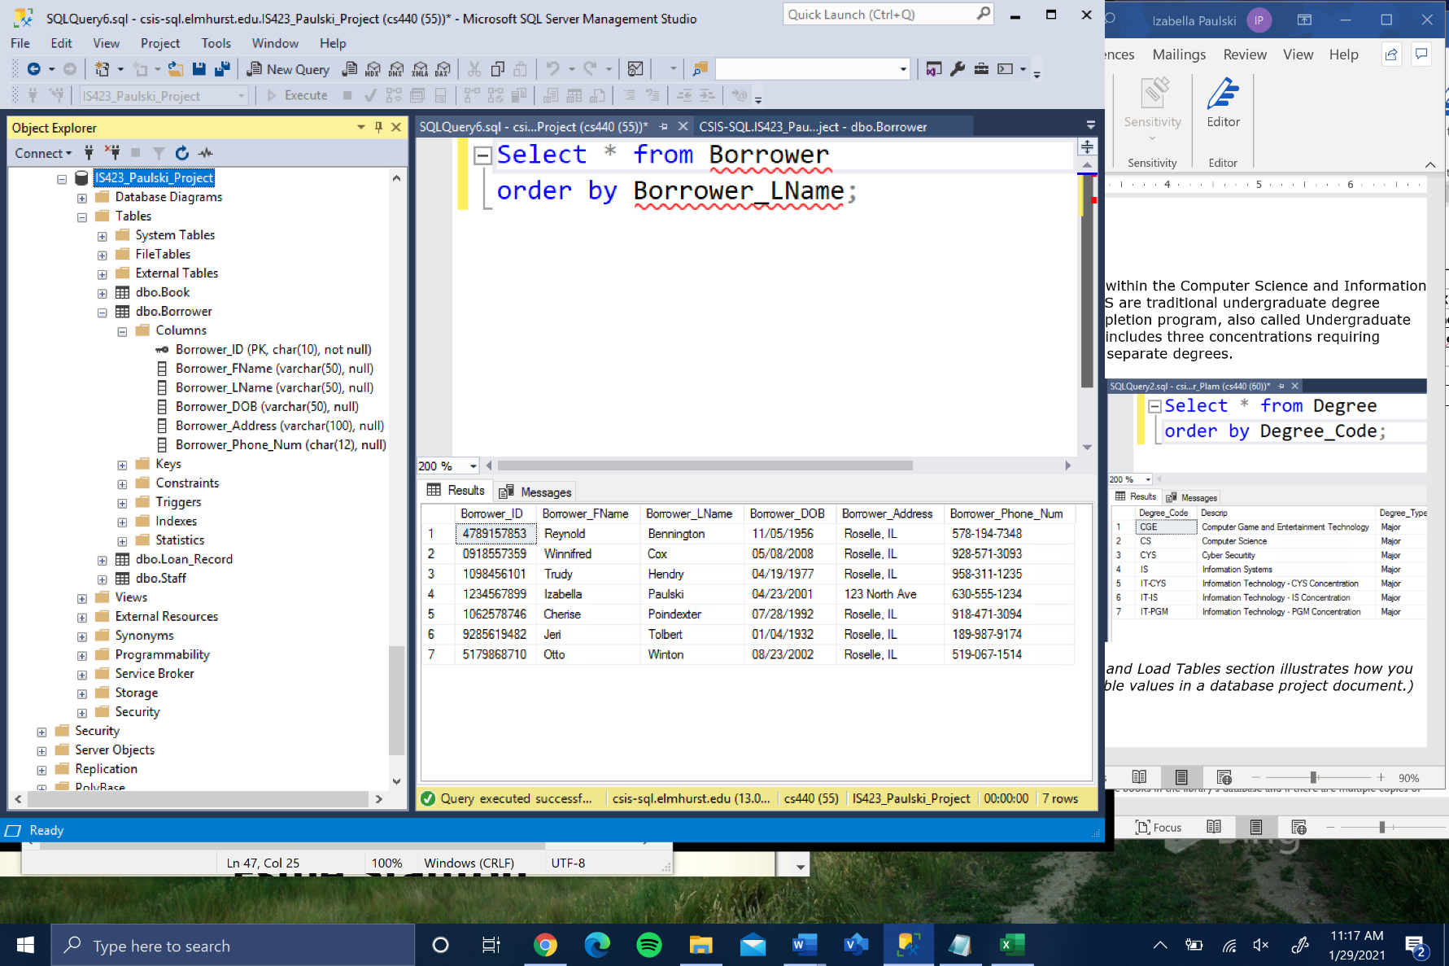The borrower table identifies all the borrowers that have a membership with Roselle Public Library.

### Loan Record Table

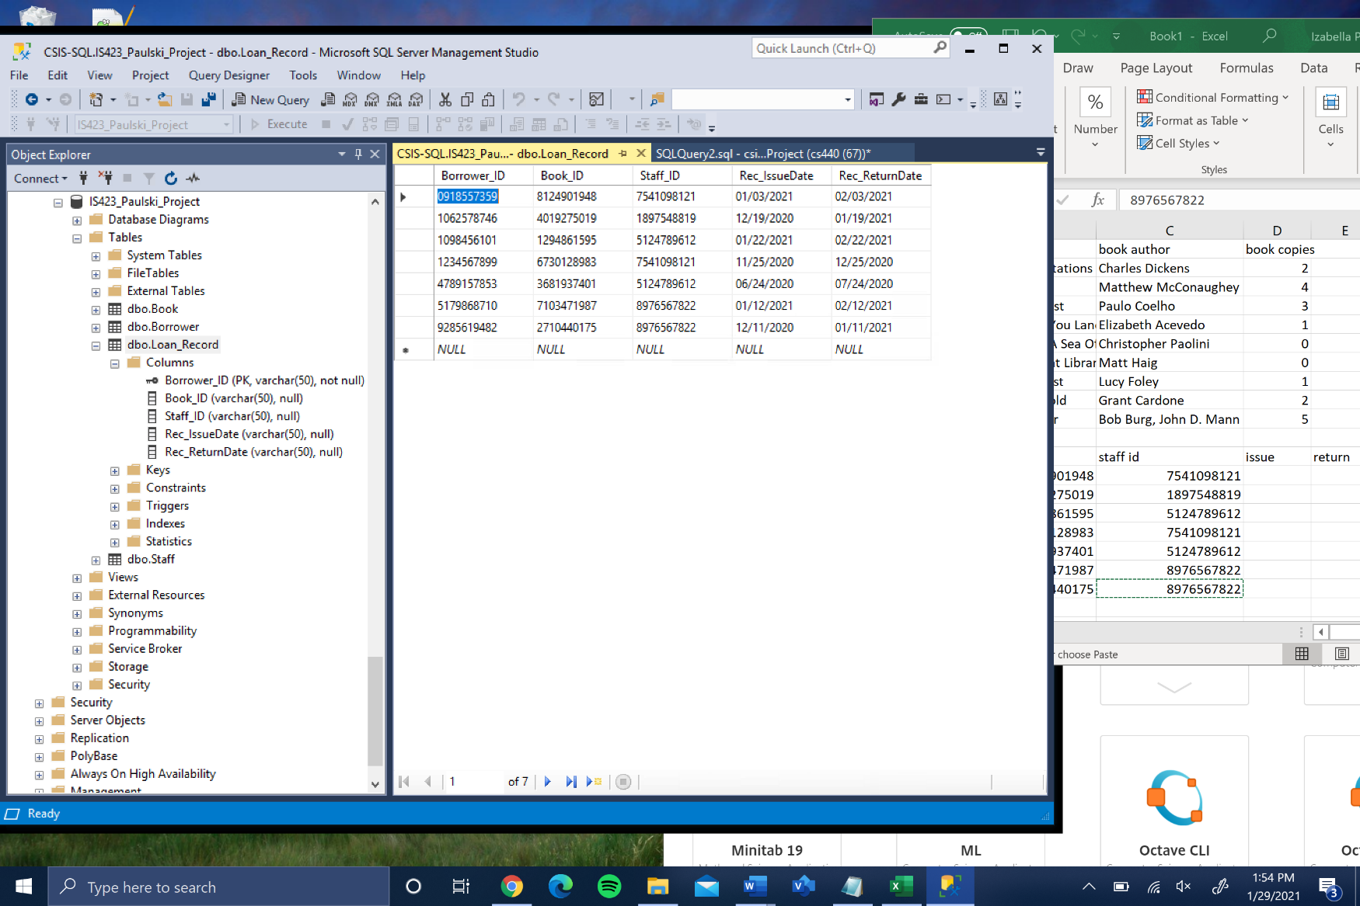The loan record table identifies the specificities involved with the loan. It contains information about the borrower, staff, book, and the status of the loan.

### Book Table

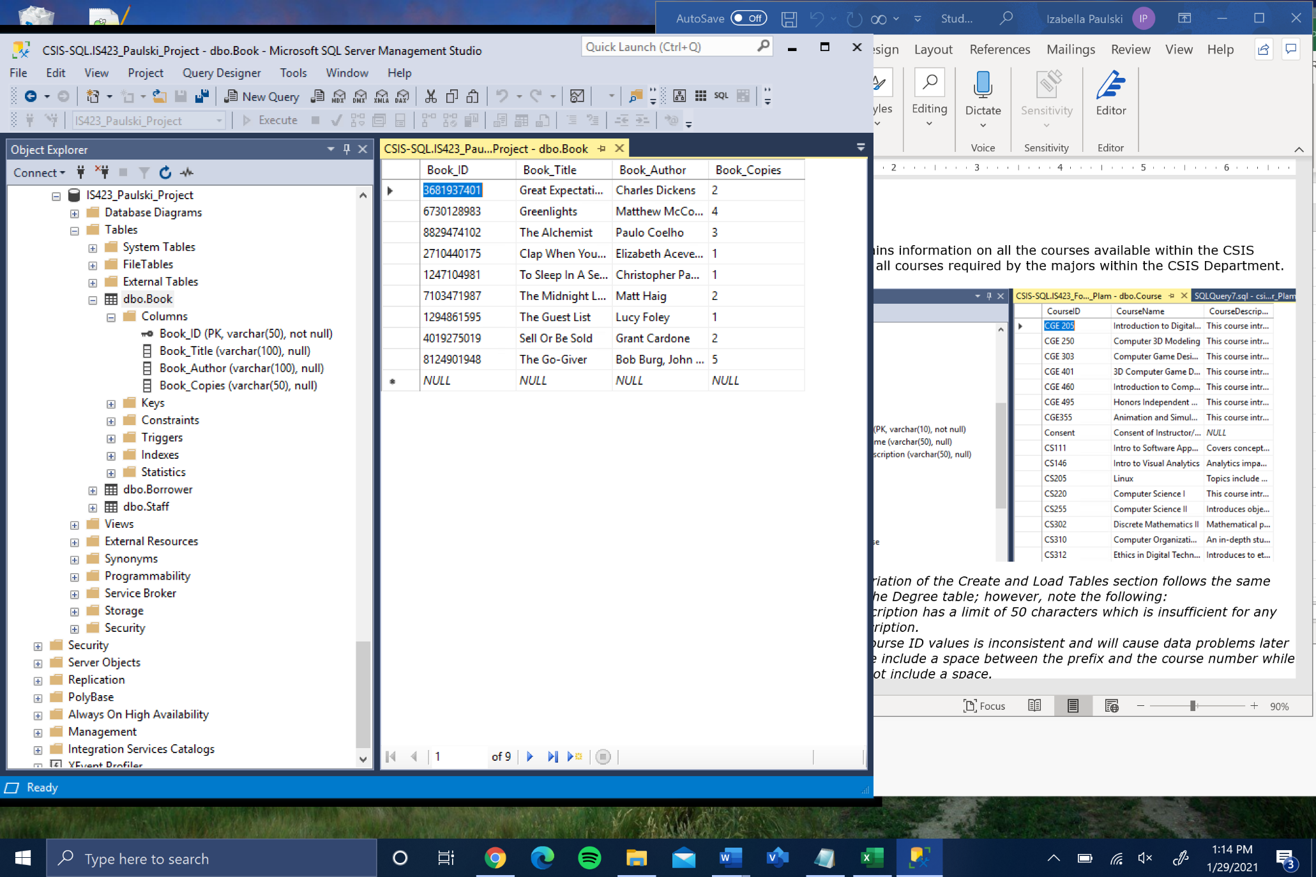The book table identifies all the books in the library’s database and if there are multiple copies of the book.

### Staff Table

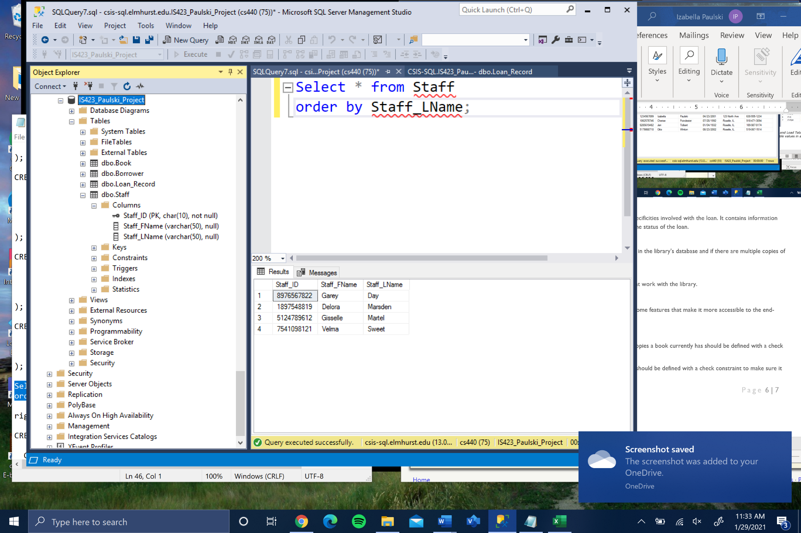The staff table identifies all the staff that work with the library.

## Database Design Issues

The design of the database is missing some features that make it more accessible to the end-users. The following are listed:

1. Domain Constraints

a. Values for the number of copies a book currently has should be defined with a check constraint.

b. Values for the return date should be defined with a check constraint to make sure it is not overdue.

2. Triggers

a. A trigger should be defined when the return date is expired.

# Section 04 – Simple and Complex Queries

## Simple Queries

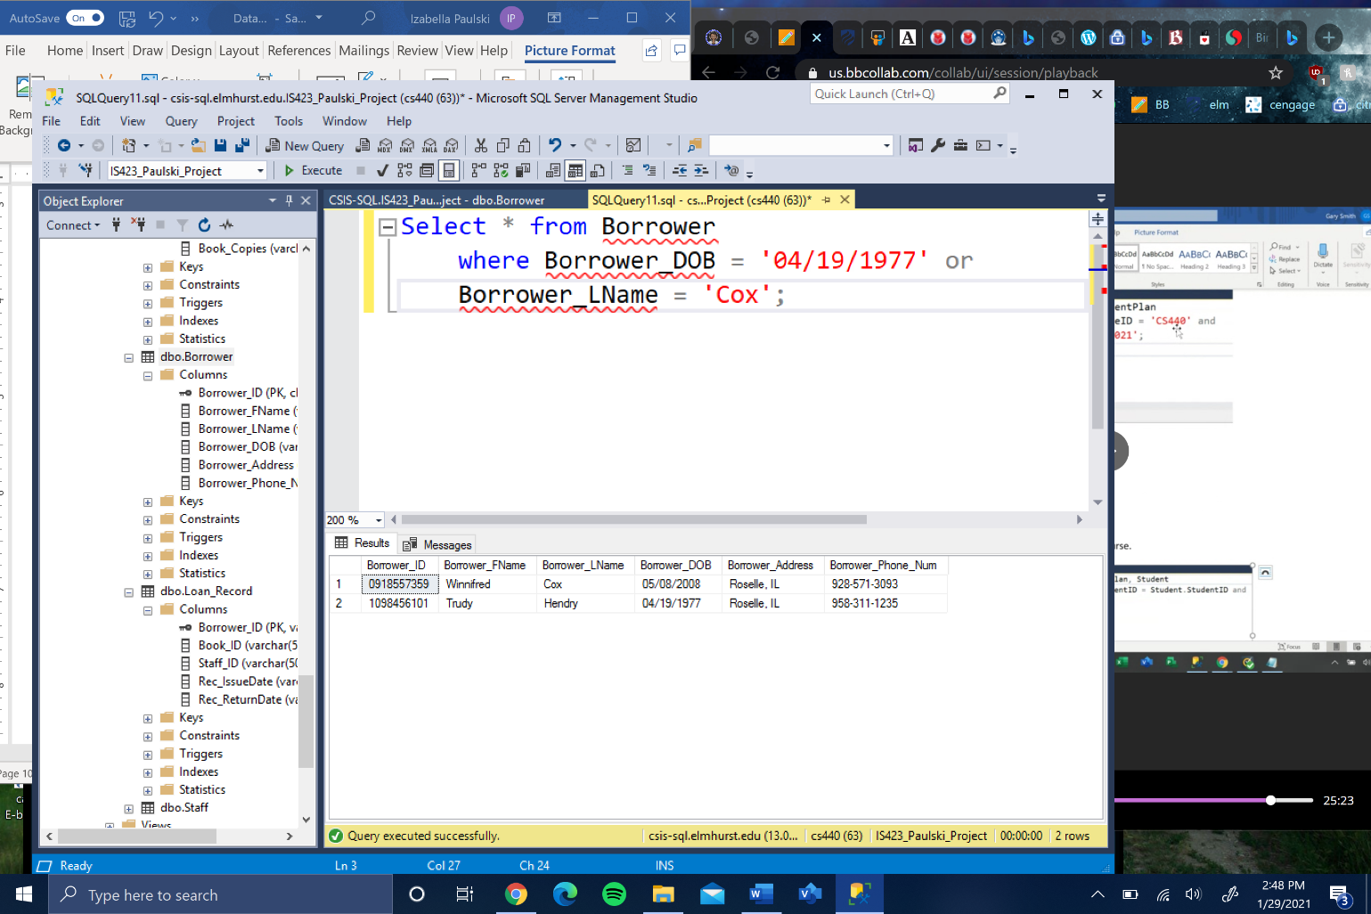BR01 – Given a date of birth or last name, identify how many borrowers loaned out a book.

BR02 – Identify how many books contain more than two copies.

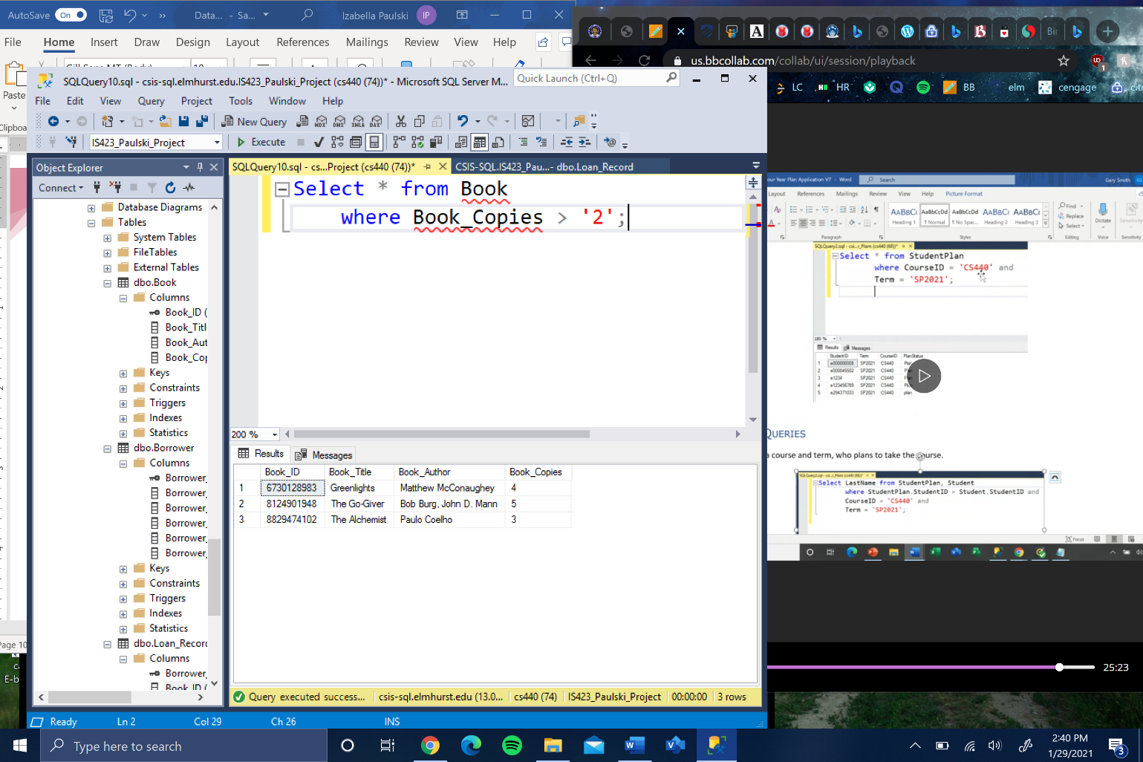

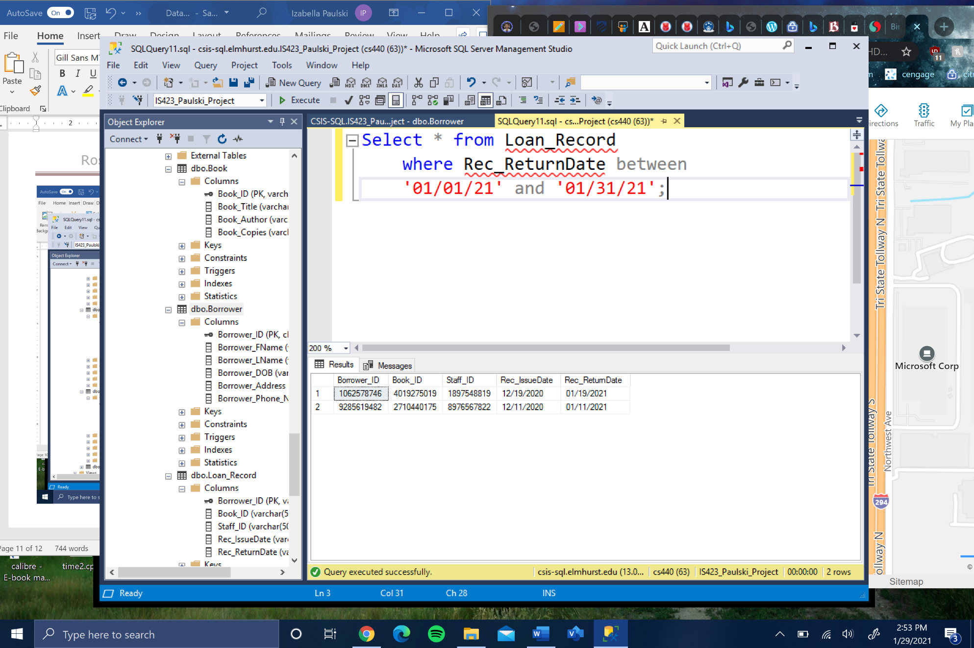BR03 – Given a books return date between two dates, identify how many books are loaned out.

BR0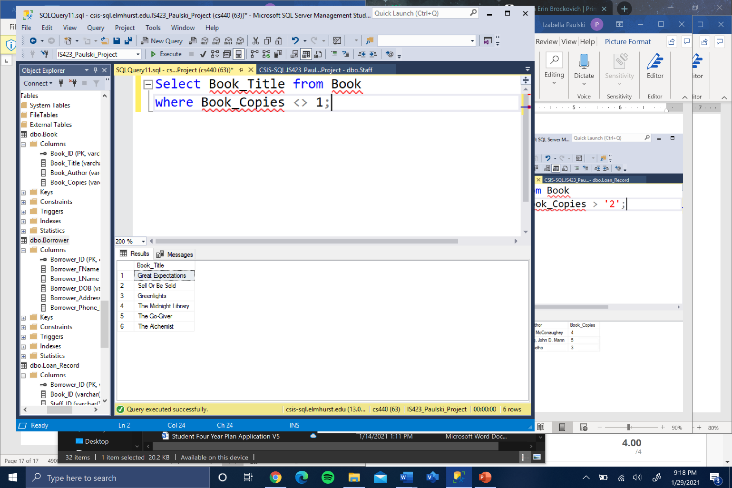4 – Given book copies that are not equivalent to 1, display the book titles.

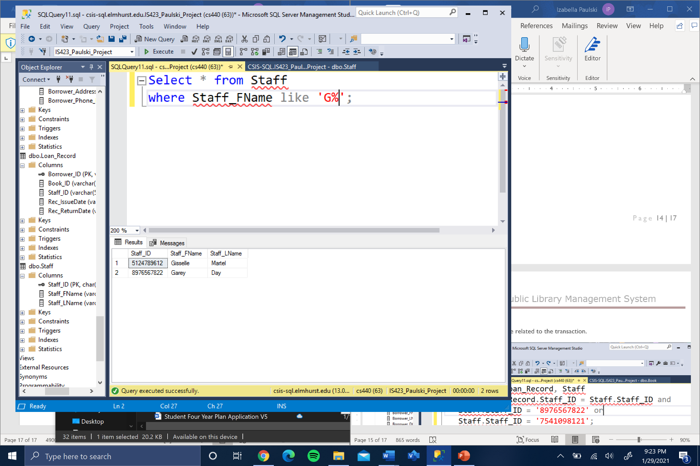BR05 – Given a staff last name starting with ‘G’, display all contents from staff.

## Complex Queries

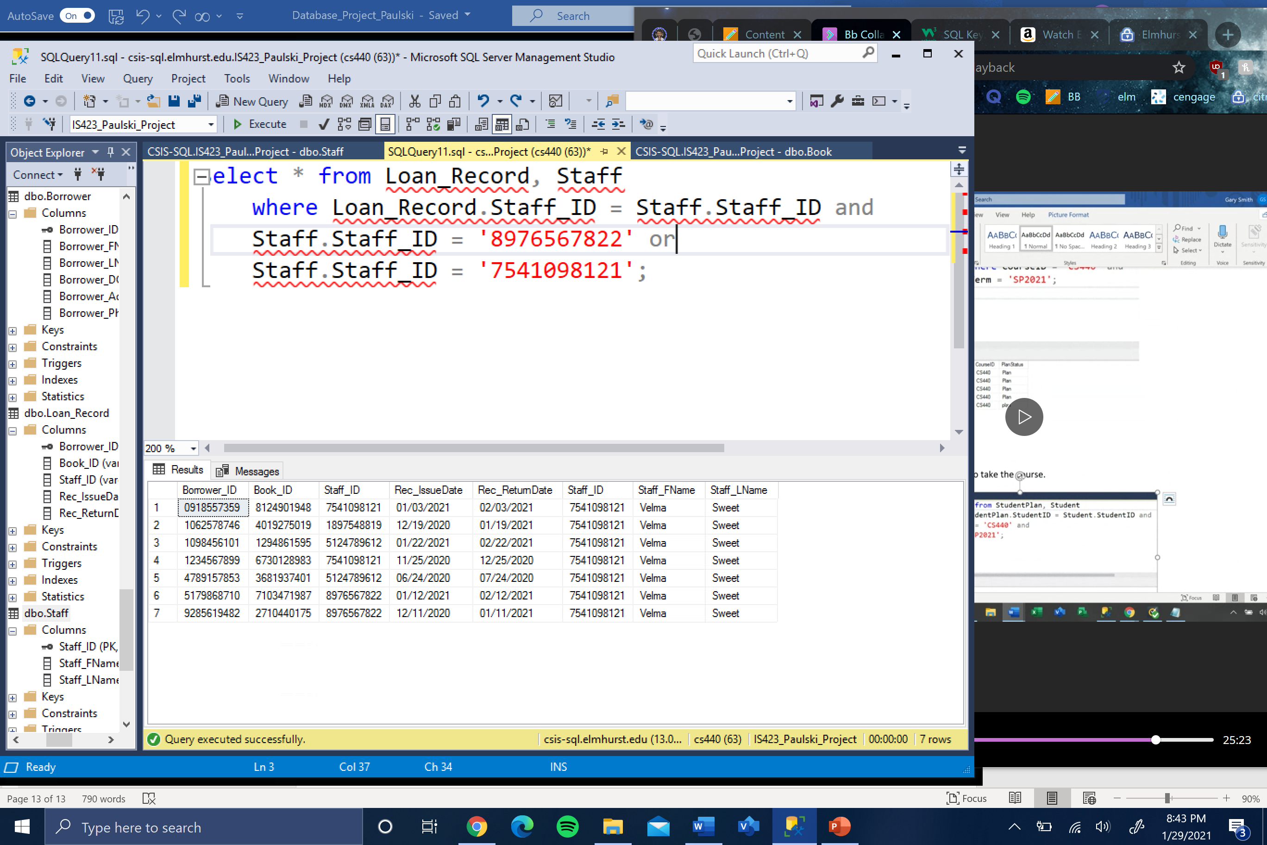BR06 – Given a Staff ID, how many borrowers are related to the transaction.

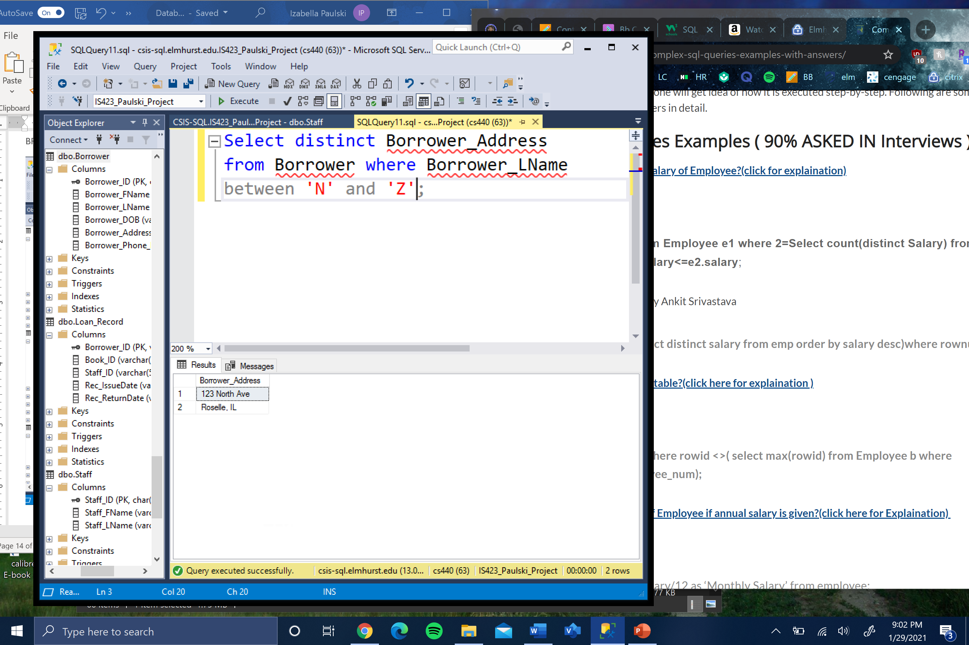BR07 – Given a customers last name between certain letters, identify unique addresses.

BR0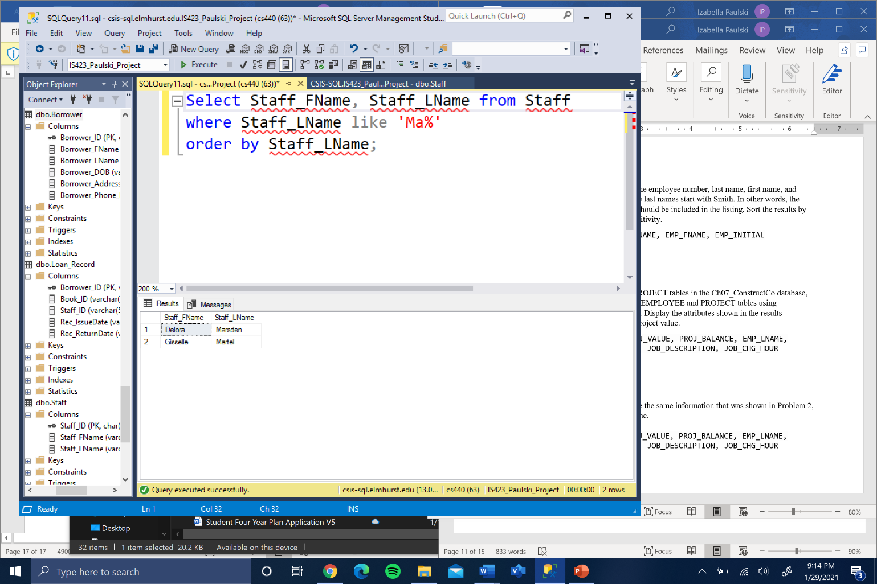8 – Given a staff last name with a constraint, identify the staff’s first and last names in order.

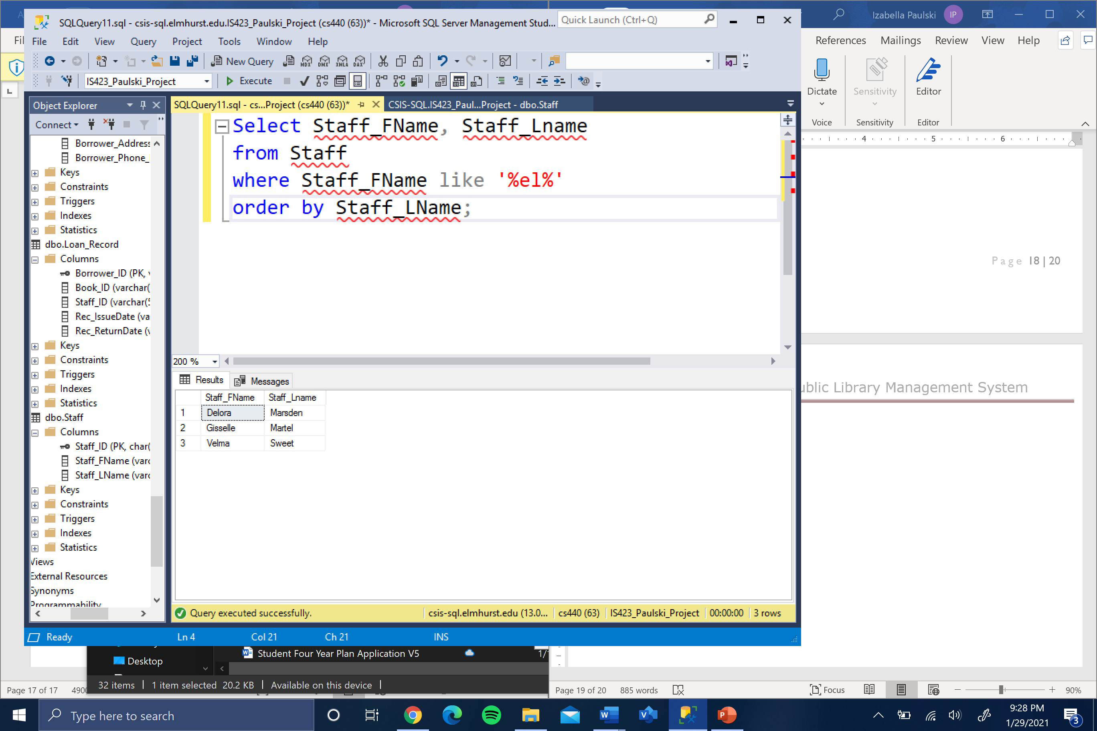BR09 – Given a staff last name with matching characters, display in order the first and last name.

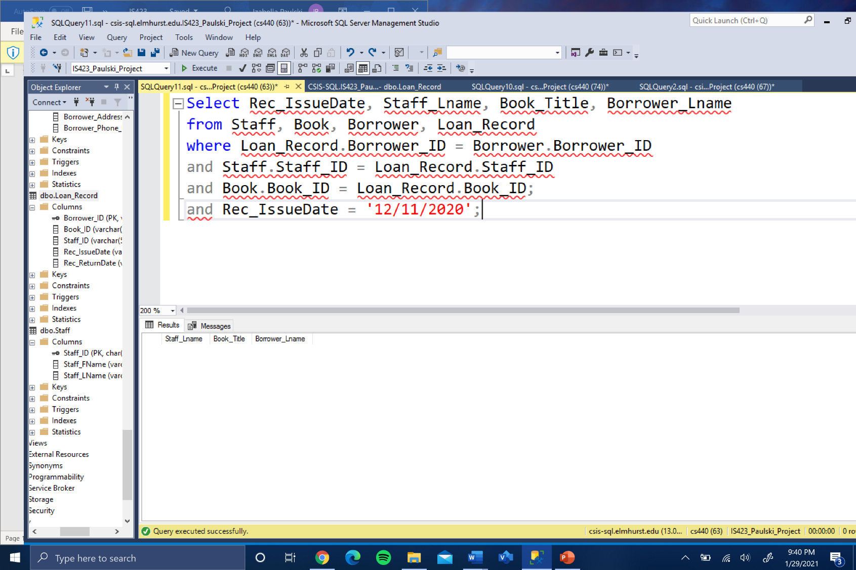BR10 – Given a staff ID, borrower ID, and book ID, identify all the issue dates on that specific date with matching ID’s.